**A Radiation Therapy Emergency Treatment Preparedness System for a Disaster Situation**

*Lixin Zhan, Leah Wolfe, Ernest Osei, Sara Kaune*

**Introduction**

Ransomware has become a big threat to healthcare IT systems. Radiation therapy (RT) program nowadays relies heavily on IT infrastructures, hence is vulnerable to ransomware attack. When under attack, we lose access to both the oncology information system (OIS) and RT file/image servers. Patient treatment plans will not be accessible and treatments have to be paused for a prolonged time. To minimize treatment interruption, we have implemented an emergency treatment preparedness system for our RT program. In a disaster situation, we should be able to continue treatment for patients ready for or under treatment.

**Methods**

A brief illustration of our Aria centric IT infrastructure is shown in Figure 1. In preparing for disaster remediation due to ransomware attacks or other unexpected incidents, we have both the backup and replication (RT-BR) component for data recovery, and the emergency treatment preparedness (RT-EP) component for continuous patient treatment before the RT program being fully recovered. We focus on the second component here.

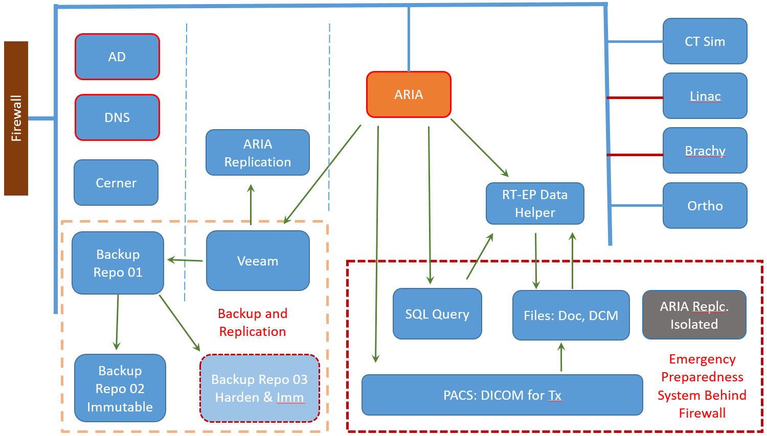

*Figure 1. Brief illustration of RT related IT infrastructure for the Emergency Preparedness System. Here ARIA stands for all key components for the ARIA system: OIS, Image, DICOM, Platform Service etc.*

Linac provides the functionality of treating patient in file based DICOM RT mode. RT-EP is to obtain the required DICOM files for patients under or ready for treatment, together with all other necessary information in performing the correct treatment.

RT-EP has been designed to have its own isolated private network behind a firewall. This firewall allows only communication initiated from inside. The only port forwarding enabled is the DICOM communication port for DICOM C-MOVE.

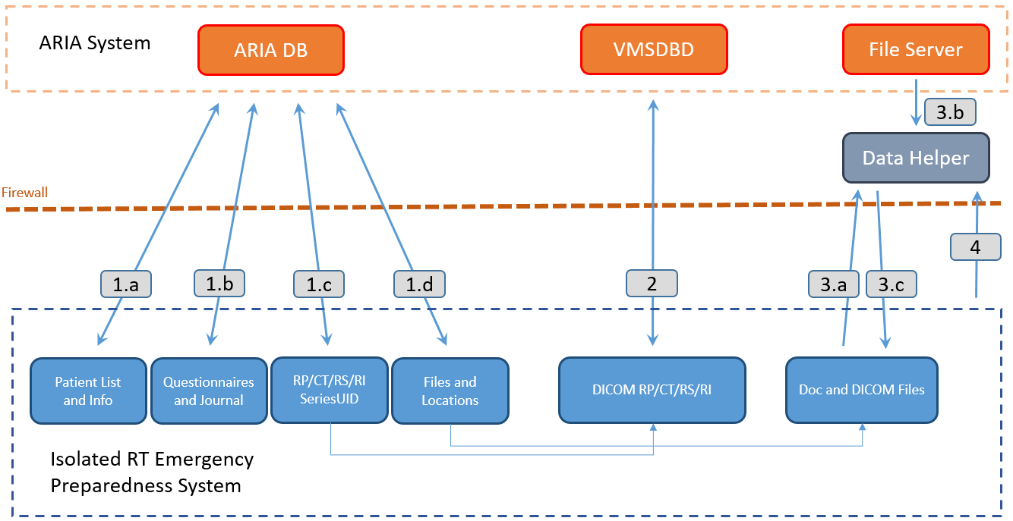

*Figure 2. RT-EP data retrieving illustration. After NIC enabled at scheduled time, 1.a-1.d: SQL queries of Aria DB; 2: DICOM C-MOVE based on SeriesUID queried from step 1.c; 3.a: files copy request based on the result of 1.d; 3.b: file copy from RT file/image server; 3.c: file copy from data helper; 4: send an organized copy of files from all previous steps to data helper. NIC will be disabled after all steps.*

Three different data retrieval processes have been implemented for obtaining patient data.

* First, SQL queries of Aria DB are performed for these information: treatment delivered on the day, treatment schedules for the next 7 days, patient simulated in the last two weeks. Also queried are some contents from Aria Questionnaires and Journal. To prepare for the DICOM retrieval next step, the SeriesUID for RT plan, StuctureSet, planning CT, and Reference Images, if applicable, are obtained. For copying necessary document type files and DICOM files from the RT file/image server, their locations and/or filenames are found out from the DB too. All above query results are saved in CSV file format for easy data processing later when required.
* Next, DICOM communication with Aria DB’s DICOM service, with default AET VMSDBD, is established. Based on the DICOM SeriesUID obtained in the previous step, DICOM C-MOVE is performed to retrieve all relevant DICOM files and saved locally for each patient. DICOM C-MOVE is time consuming, hence only treatment required DICOM files will be worked on.
* The last step of data retrieval is to copy other documents and DICOM files from Aria directly. Those files cannot be obtained through SQL query or DICOM communication, or time consuming through them. A data helper server on the Aria network has been set up for caching those files. Files located from the first step are copied from this data helper instead of Aria servers directly. Data helper resolves the difficulties in file sharing between the Linux based RT-EP system and AD domain controlled Aria system. This also helps reducing the attack vectors to the critical clinical servers.

After all data successfully received, we organized the data to be individual patient based and make a full copy of them to the helper server for the convenience of data checking and verification later. The RT-EP system disables its network interface from now on and put itself offline till the next scheduled data retrieval time. The steps above are fully automated.

**Results and Conclusion**

An emergency treatment preparedness solution has been designed and implemented. It is able to successfully retrieve all necessary information in preparation for disaster situations. Together with the development of proper department emergency policy, it is expected to help minimize any delayed unfavorable effects for patients under treatment even if the clinical RT system is not available for a prolonged period.